1. **Create a GUI in C#**

**Final Outcome:**

Add an image

Have a title

**Main Menu**

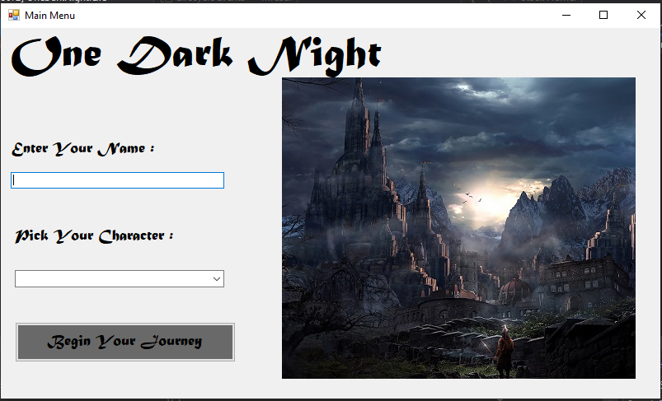

Text box

Label for name and character

Create a button that will take you to the next form.

Combo Box

**Second Form**

Dynamic – Data will change depending on the first form.

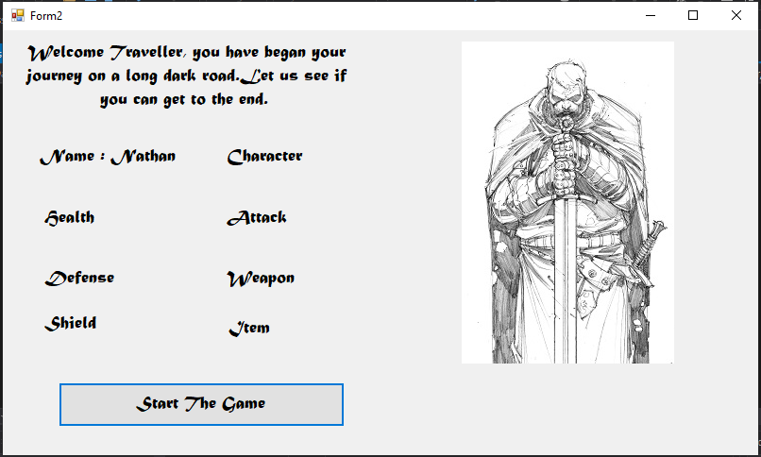

Label for character

Properties

Create a button that will take you to the next form.

**Third Form**

Create labels with images

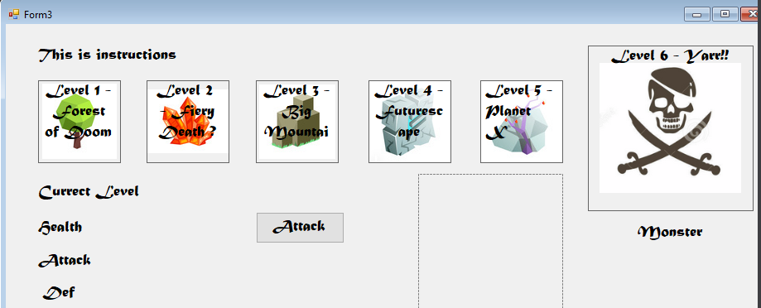

Labels for the monster properties

Create Empty Picture Box

Create Attack button

Create method so when labels are clicked Message box appears

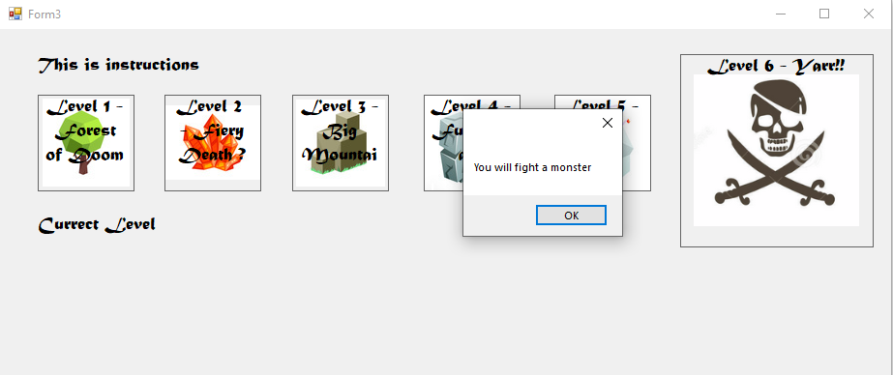

Attack button set to invisible

Labels for the monster properties set to invisible

**Tasks**

|  |  |
| --- | --- |
| **-> Start a new project where you can create a GUI** |  |
| **-> Create 3 forms.** |  |
| **-> Add a start button that links the first form to the second and the second to the third.** |  |
| **-> Create the title and the image for the main menu**  **-> Add a textbox and a dropdown box onto the main menu.** |  |
| **-> pass the information from the textbox and dropdown box onto the second form.** |  |
| **-> Create a method that will change the image depending on the user choices from the main form.** |  |
| **-> Create the levels in the final form.** |  |
| **->Create the labels for the monster property** |  |
| **-> Create a method called setGame that sets all monster property labels to invisible.** |  |
| **-> Create a method called createMonster that shows a message box saying “you will fight a monster”.** |  |
| **-> For each label, call the createMonster method.** |  |

**Challenges**

|  |  |
| --- | --- |
| * **Create a form that allows you to save your progress using serialisation** |  |
| * **Create a form that allows you to load a save game.** |  |